2022 Pistoleta
Rogue Valley, Southern Oregon
13.2% alc./vol.
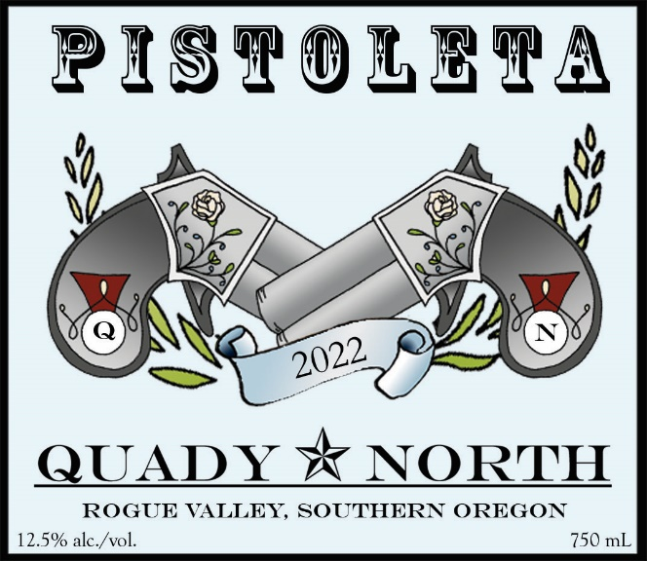
Total Production: 1,165 cases
Release Date: January 2022
Suggested Retail Price: $20.00/bottle
Varietals: 31% Viognier, 29% Roussanne, 25% Marsanne, 10% Grenache Blanc, 5% Vermentino

Winemaker Notes: This is our 13th vintage of “Pistoleta”; our signature Rhone White blend. As in other years, most of the wine is co-fermented to naturally optimize wine chemistry. In the end, we adjust the blend by adding additional Viognier and Grenache Blanc, as needed.

Tasting Notes: Stone fruit flavors, including apricot and nectarines predominate, with notes of honey and citrus. The wine runs the edge of crispness and unctuousness, with a lip smacking quality. Consumers will find that over time, this wine will lose its fruit character, but gain in texture. We recommend aging no longer than a year or two.

Chemistry: 22.6 Brix (Average) at harvest. pH: 3.33, TA: 7.0 g/L, r.s. 0.3 g/100mL

Fermentation: Whole cluster pressed. Primary fermentation in stainless steel (84%) using “Aroma White” yeast, and barrel fermented (16%) in Cocciopesto tank, Acacia wood and French Oak. Most of the wine was co-fermented to improve integration and optimize wine chemistry.

Aging: Lees stirred to promote body post-fermentation, then racked. Fined with bentonite for heat stabilization.

Accolades:
2022: Not yet reviewed
2021: 89 pts. Wine Enthusiast “Best Buy”
2019: 91 pts. Wine Enthusiast “Editor’s Choice.”

Quady North ~ PO Box 697 Jacksonville, OR 97530
541.702.2123 Fax: 541.702.2134 info@quadynorth.com www.quadynorth.com

