2021 Chardonnay “Layne Vineyard”
Applegate Valley, Southern Oregon
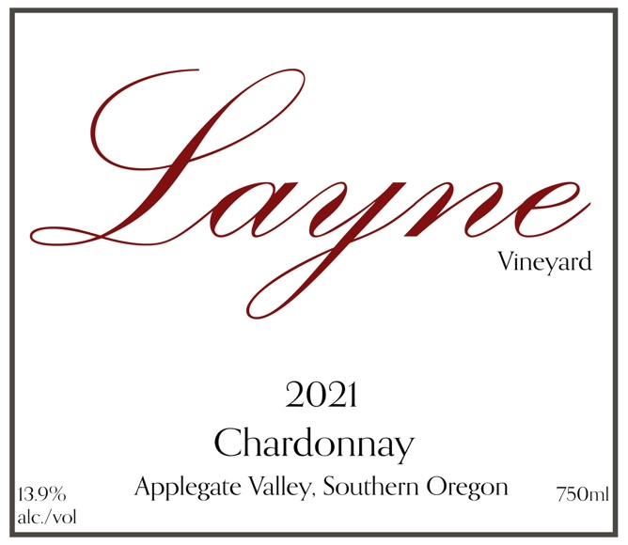

Total Production: 101 cases

Release Date: September 2023

Suggested Retail Price: $32

Alcohol: 13.9%

Farming: LIVE-certified wine

Winemaker Notes: The Layne Vineyard sits at the end of a long driveway, following the Caris Creek draw back into the hills above the Valley. Like many sites in the Applegate, you would never know that the vineyard existed, and yet, there it was, 35 acres of old vines, some of the very first planted in Southern Oregon.
Roger and Barrie Layne moved to the Applegate from California in the early 1970’s. Barrie hailed from Napa, but her family owned a dairy there, not grapevines. However, on their first visit to the Applegate, they met Dick Troon who, in 1972, had already planted 10 acres of grapevines. They decided to follow suit, and planted some of their own the following year, including Southern Oregon’s first Merlot vines.
In 2015 Roger Layne asked us to make a stand-alone Merlot. In concert with the Layne’s, we decided to produce it and label it under the “Layne Vineyard” label. Over the years, we expanded the lineup to include all the varieties first planted in 1973, including Chardonnay and Cabernet Sauvignon.

Sources: This is 100% Chardonnay from old vines in the Layne Vineyard.

Tasting Notes: The nose strikes you first with a candied lemon peel, revealing next baking spice notes with subtle coconut aromas. The palate reveals ripe pear and peony flowers, with a creamy texture like toasted meringue that coats the mouth.

Fruit Handling: 100% direct to press.

Fermentation: Fermented in 60-gallon French Oak barrels.

Aging: French Oak for 11 months, including 16% new oak. Regular stirring sur lie through barrel ageing.

