2019 Cabernet Franc
Mae’s Vineyard
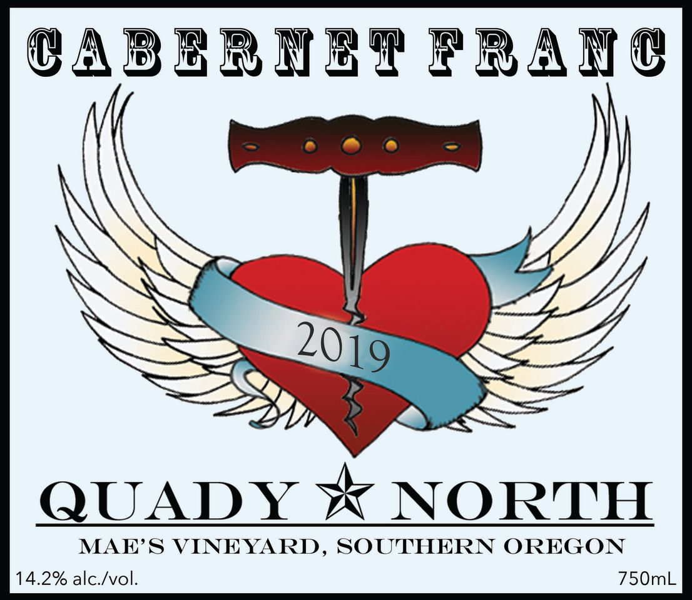
Total Production: 98 cases
Release Date: Spring 2023
Price/bottle: $39
Applegate Valley
14.2% alc./vol.

Winemaker Notes: In 2006, we planted our Estate Vineyard (“Mae’s Vineyard) to Syrah, Cabernet Franc and Viognier. Cabernet Franc has proven to be a standout from the Estate. Mae’s vineyard is denoted by red soils, south facing slopes, and moderating afternoon breezes. This combination serves to highlight the natural varietal character of Franc, while making for supple tannins.
This is the first single vineyard bottling of Mae’s Cabernet Franc we have produced since 2014. A string of low yields meant that there was not enough available to justify an additional bottling.
Fruit Handling: Destemmed and sorted, 100% whole berry to 1 ton open top fermenters and 2 ton open top tanks. Cold soaked 72 hrs. Pressed at 0B , and barreled next day.
Aging: Aged 18 months in 35% new, F.O., 35% 1 yo FO, 30% 3 yr 58 gal neutral F.O. Lees stirred throughout the first quarter. Racked 1 x/yr.
Bottling: Bottled unfined and unfiltered.
Blending: 100% Cabernet Franc, Mae’s Vineyard
Chemistry: pH:3.55, TA: 6.5 g/L, Brix at harvest: 23.5B
Pair with: Lamb pairs well with Cabernet Franc. Try this wine with a frenched cut of lamb, roasted and topped with a mint gremolade.

